**Branching strategies & Code Promotion in GitHub**

**Branching strategies in GitHub:**

**Create following Branches in Git hub.**

**master**

**prod**

**preprod**

**dev**

**Branching strategies:**

Branching strategies in GitHub are important for managing and organizing workflows when working with teams or solo on projects. Here are some common branching strategies:

**master**: The main branch.

**prod**: This branch contains the latest prod changes. containing stable and production-ready code.

**preprod:** This Branch contains the latest preprod changes.

**dev**: This branch contains the latest development changes. It's the default branch where features are merged into.

**feature**: Feature branches are created from dev branch and are used to develop new features. Once the feature is complete, it's merged back into dev branch.

**Workflow :**

Go to github. Open repo. Click on master then type “prod” then click on **Create branch: prod from ‘master’.**

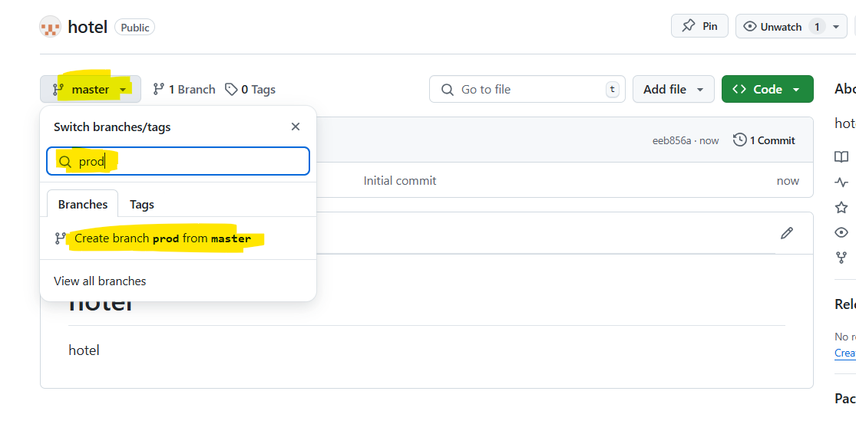

Next Click on prod then type “preprod” then click on **Create branch: preprod from ‘prod’**

Next Click on preprod then type “dev” then click on **Create branch: dev from ‘preprod’**

Now it will show we have 4 branches and all the codes were copied from upper branches.

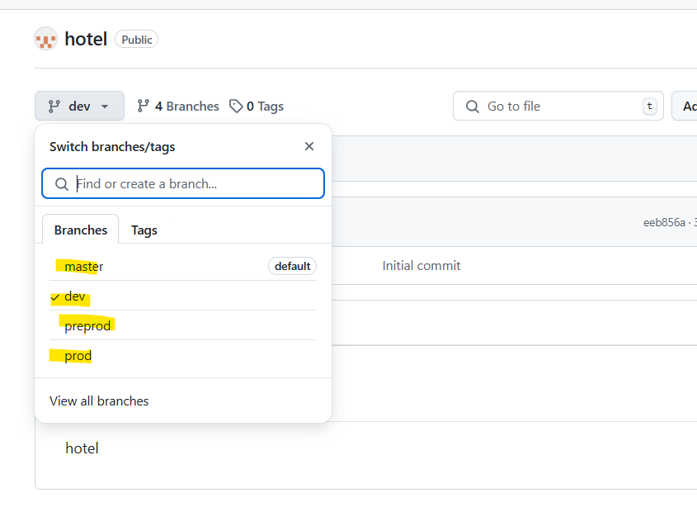

**Code Promotion in GitHub:**

Code promotion in GitHub refers to the process of moving changes from one environment (like development or staging) to another (like production). This typically involves using branches to represent different stages of the development lifecycle.

**WorkFlow :**

**Create a Pull Request:**

When code is ready to be promoted, create a PR from one branch (e.g., feature) to the target branch (e.g., dev).

**Review and Merge:**

After code review, the PR is merged.

**Deploy to Target Environment:**

After the PR is merged, deploy the code to the appropriate environment.